|  |  |  |  |  |  |  |
| --- | --- | --- | --- | --- | --- | --- |
| Variable Name | Unique Variables | Missing % | Mean | Variance | Median | Correlation with OD600 |
| OD600 (nm) | 557 | 10% | 53.3 | 1862.17 | 52.00 | 1.00 |
| Wet Cell Weight (g/L) | 255 | 43% | 170.2 | 3375.22 | 194.00 | 0.79 |
| Agitation (rpm) | 601 | 0% | 1088.6 | 42819.21 | 1185.11 | 0.07 |
| Air (%) | 370 | 0% | 93.4 | 245.89 | 99.58 | -0.15 |
| Dissolved Oxygen (%) | 676 | 0% | 53.4 | 511.37 | 41.59 | -0.60 |
| Gas Flow | 389 | 0% | 4.4 | 1.6 | 5.0 | -0.07 |
| Oxygen Percentage | 372 | 0% | 5.7 | 168.83 | 0.38 | 0.10 |
| pH | 601 | 0% | 6.6 | 0.05 | 6.72 | -0.04 |
| Feed (%) | 156 | 0% | 10.8 | 76.62 | 12.50 | 0.51 |
| Temperature (0C) | 248 | 0% | 29.6 | 1.64 | 30.00 | -0.23 |
| Glycerol (g/L) | 28 | 75% | 0.8 | 4.07 | 0.00 | -0.57 |
| Glucose (g/L) | 294 | 24% | 3.8 | 63.91 | 0.00 | 0.12 |
| Acetate (mmol/L) | 384 | 24% | 25.8 | 8084.4 | 1.91 | -0.03 |
| Phosphate (mmol/L) | 335 | 29% | 10.2 | 113.84 | 7.03 | -0.85 |

|  |  |  |  |  |  |
| --- | --- | --- | --- | --- | --- |
| Variable Name | Number of Unique Values | Missing (%) | Mean | Variance | Median |
| OD600 (nm) | 557 | 10% | 53.3 | 1862.17 | 52.00 |
| Wet Cell Weight (g/L) | 255 | 43% | 170.2 | 3375.22 | 194.00 |
| Agitation (rpm) | 601 | 0% | 1088.6 | 42819.21 | 1185.11 |
| Air (%) | 370 | 0% | 93.4 | 245.89 | 99.58 |
| Dissolved Oxygen (%) | 676 | 0% | 53.4 | 511.37 | 41.59 |
| Gas Flow | 389 | 0% | 4.4 | 1.6 | 5.0 |
| Oxygen (%) | 372 | 0% | 5.7 | 168.83 | 0.38 |
| pH | 601 | 0% | 6.6 | 0.05 | 6.72 |
| Feed (%) | 156 | 0% | 10.8 | 76.62 | 12.50 |
| Temperature (0C) | 248 | 0% | 29.6 | 1.64 | 30.00 |
| Glycerol (g/L) | 28 | 75% | 0.8 | 4.07 | 0.00 |
| Glucose (g/L) | 294 | 24% | 3.8 | 63.91 | 0.00 |
| Acetate (mmol/L) | 384 | 24% | 25.8 | 8084.4 | 1.91 |
| Phosphate (mmol/L) | 335 | 29% | 10.2 | 113.84 | 7.03 |
| Titer | 20 | 97% | 0.638 | 0.584 | 0.415 |

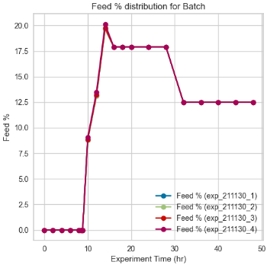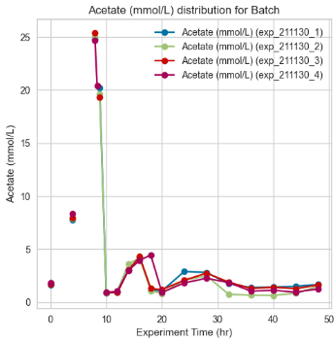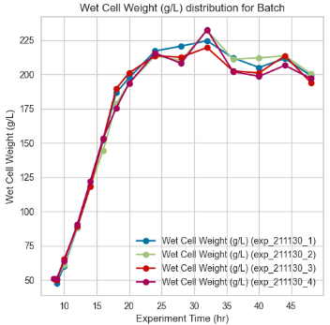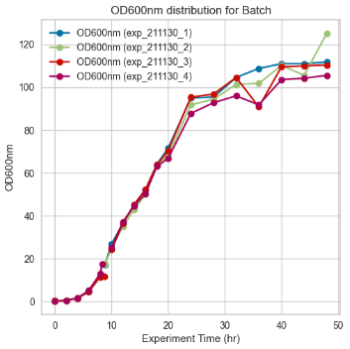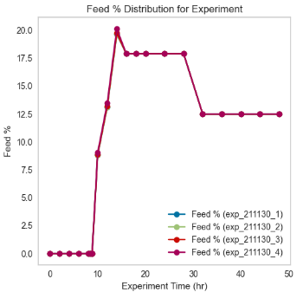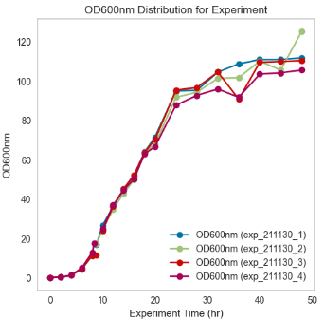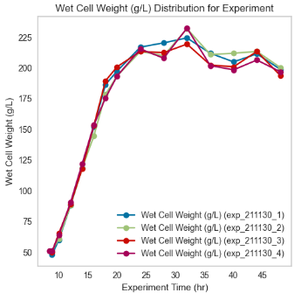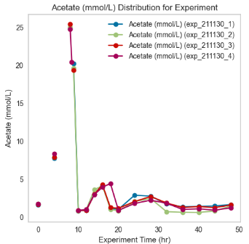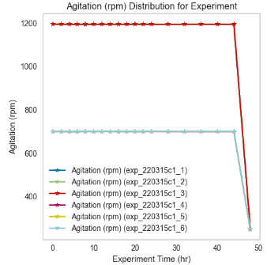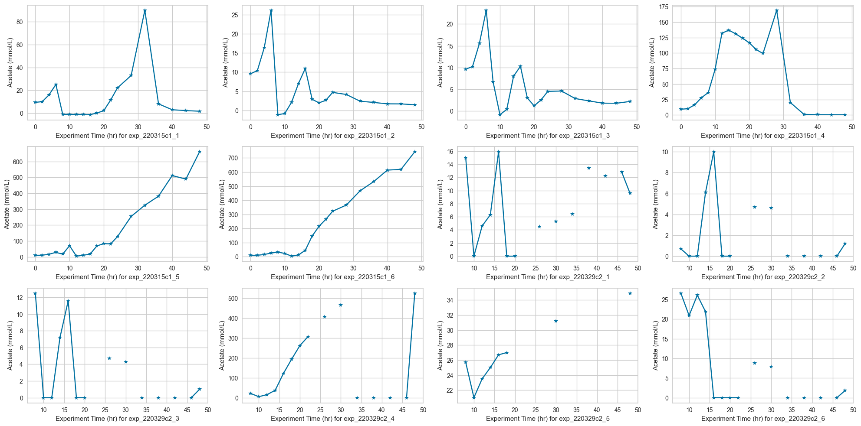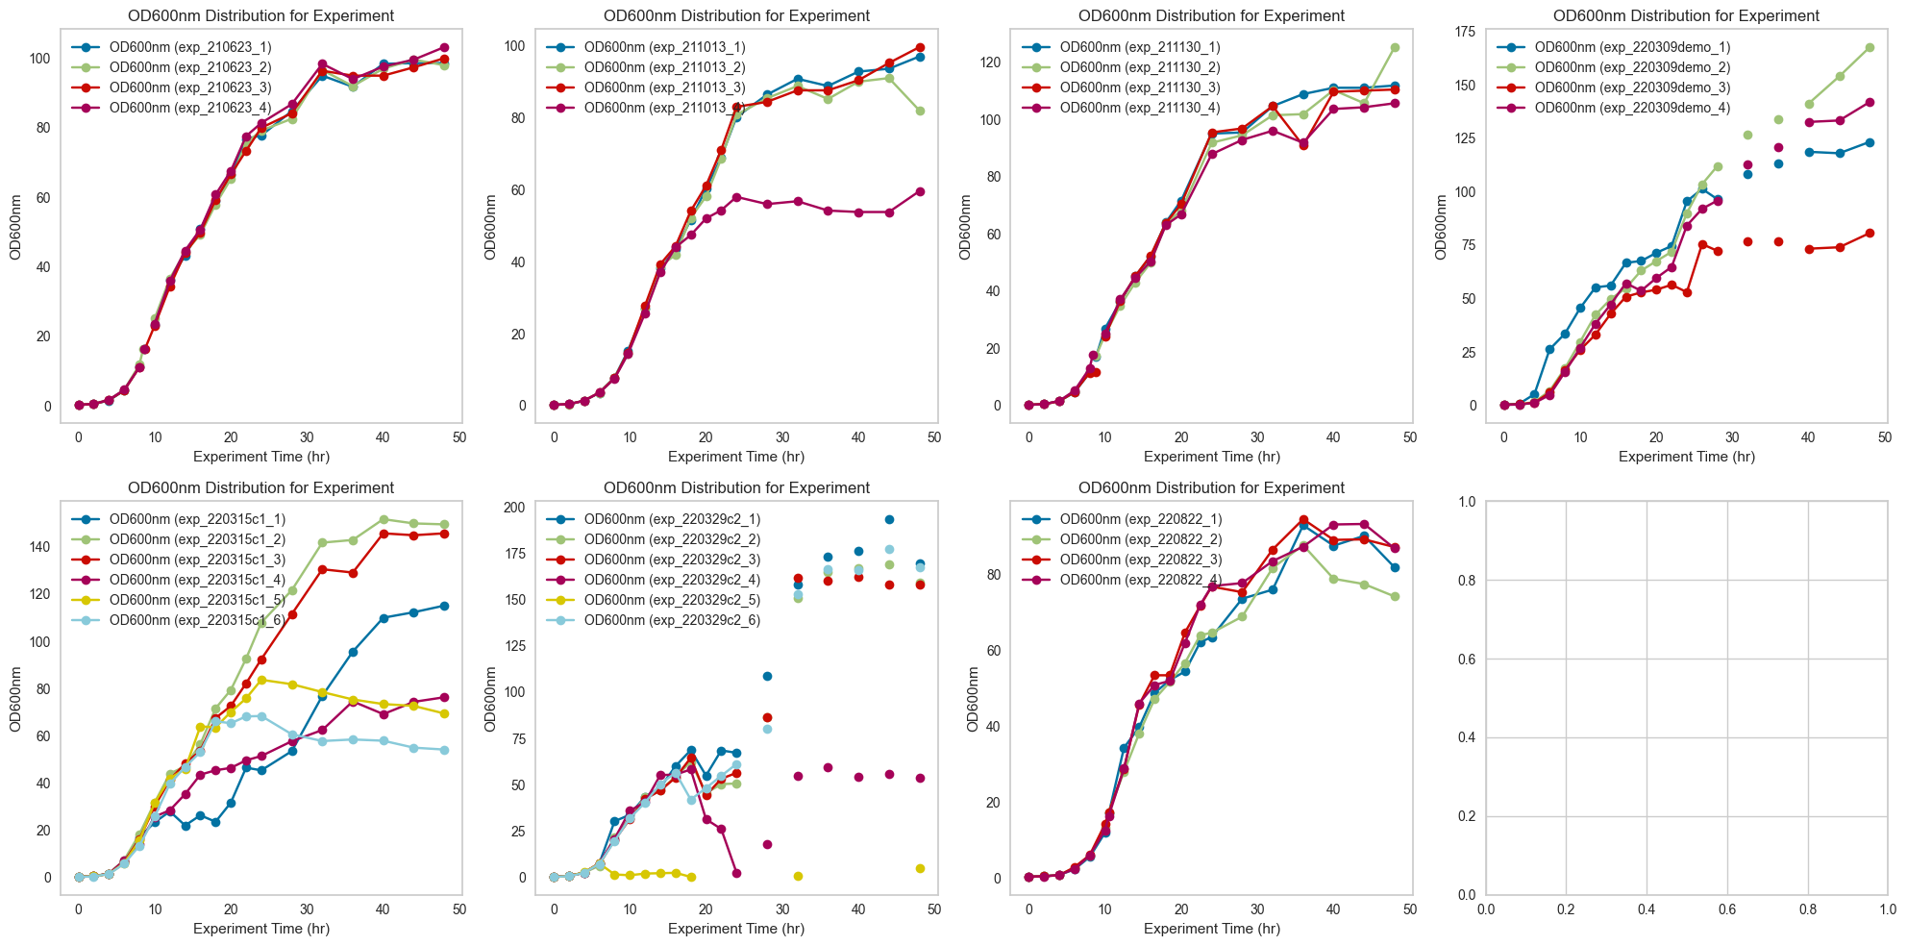

The feed for this experiment contains 50% glucose solution.

When Acetate production is above 5mmol/L, we add more feed

The equations for transforming a time variable into cyclical features using sine and cosine functions are derived from the properties of a circle, specifically the unit circle in trigonometry. Given a time variable *t* and a cycle period *T* (for your case, 48 hours), the equations for the sine and cosine transformations are:

**Sine Transformation:**

time_sin=

**Cosine Transformation:**

time_cos=

**Explanation:**

* *t*: Represents the time variable, which could be in hours, days, or any other unit of time relevant to your dataset.
* *T*: Represents the total period of the cycle. In your case, this is 48 hours, indicating that the time variable completes a cycle and resets every 48 hours.
* : This term normalizes the time variable *t* to a scale from 0 to 2*π*, where 2*π* radians is equivalent to one full cycle around the unit circle. The division by *T* scales the time variable according to the length of the cycle, ensuring that *t*=*T* corresponds to one complete revolution around the circle.
* sin and cos: The sine and cosine functions then map this normalized time onto the y-axis and x-axis, respectively, of the unit circle. This transformation converts linear time into two dimensions that loop back on themselves, capturing the cyclical nature of time.

These transformations ensure that time values close to each other in the cycle (e.g., 0 and 48 hours) are also close in the transformed feature space, preserving the cyclical continuity of the time variable.